A268-Asia-Nepal-Tara-Bronze-1998

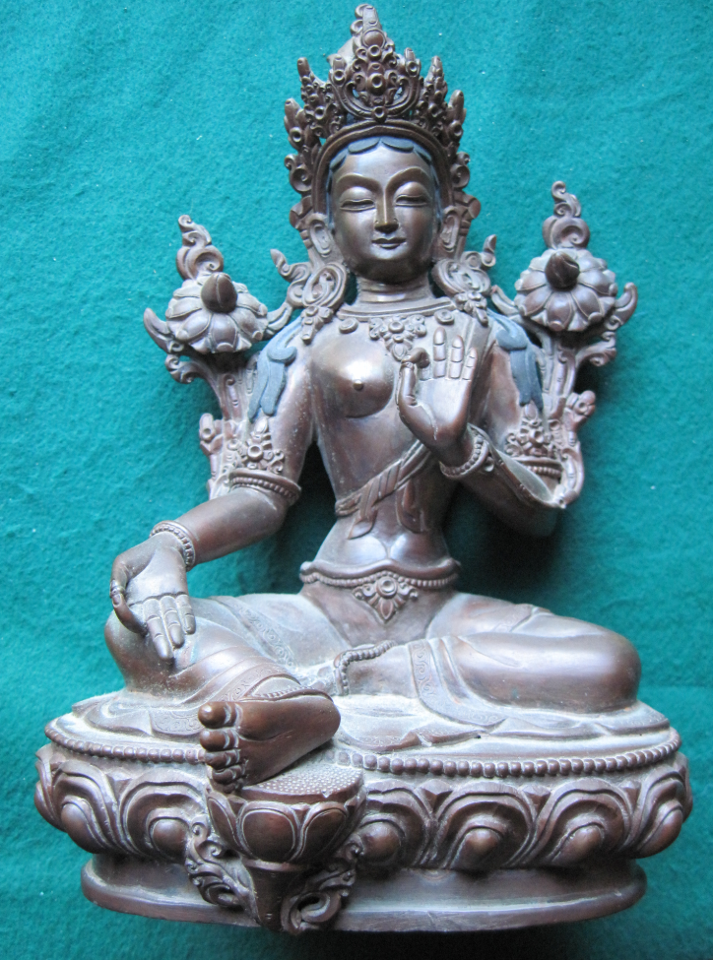 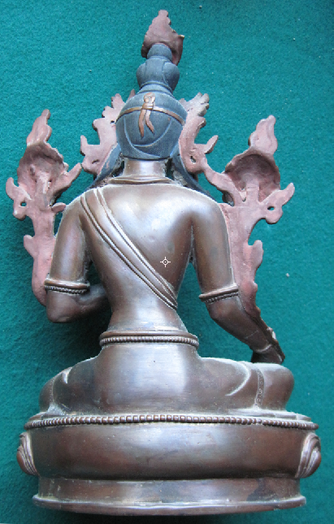 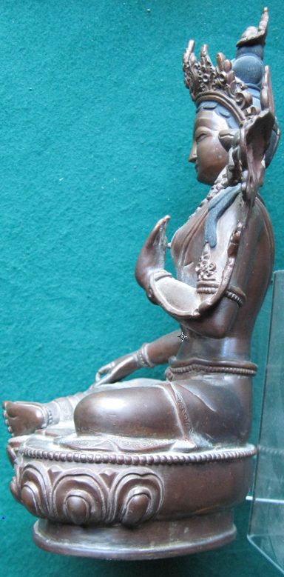

Figs. 1-3. Nepal-Tara-Bronze-1998

**Case no.: 3**

**Accession Number: A268**

**Formal Label:** Nepal-Tara-Bronze-1998

**Display Description:**

Tara in Tibetan Buddhism, is a female Bodhisattva in Mahayana Buddhism who appears as a female Buddha in Vajrayana Buddhism. She is known as the "mother of liberation", and represents the virtues of success in work and achievements. Tara is a tantric meditation deity to develop certain inner qualities and understand outer, inner and secret teachings about compassion and emptiness.

This is an example of fine craftsmanship in producing a bronze Tara statue in a Patan, Kathmandu atelier, Nepal, 1998.

**LC Classification**: BQ394

**Date or Time Horizon:** 1998

**Geographical Area:** Patan, Kathmandu atelier, Nepal

**Map, GPS coordinates:** 27.71513 85.31005;40° 26' 46" N 79° 58' 56" W

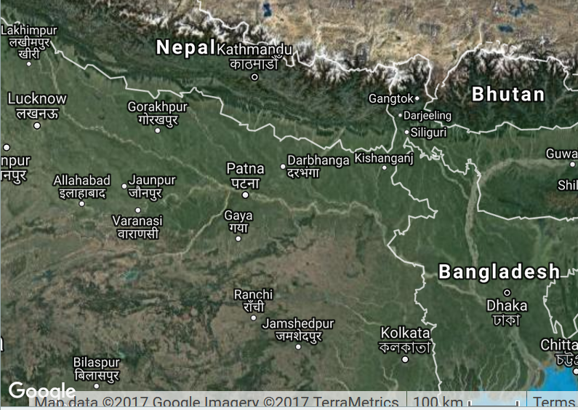

Fig. 4. Map showing Kathmandu in Nepal and surrounding countries.

**Cultural Affiliation:** Patan, Kathmandu atelier, Nepal

**Medium:** bronze

**Dimensions:** H 225.57 mm; 8.88 in

**Weight: 1328 gm; 2 lb 14 ¾ oz**

**Condition: original**

**Provenance:** Patan, Kathmandu atelier, Nepal

**Discussion:** The atelier movement in employing Nepalese youth as artists is making great headway in revitalization of Buddhism in Kathmandu valley.

**References:**

LeVine, Sarah and David N. Gellner. 2007. *Rebuilding Buddhism: the Theravada movement in twentieth-century Nepal*. Cambridge, Massachusetts London, England Harvard University Press.